Theater is the most prevalent category, It has maximum in crowd funding from May to July. And if the Theater category is removed, January has the highest number of crowdfunding.Following are the details from the excel sheet.

Total

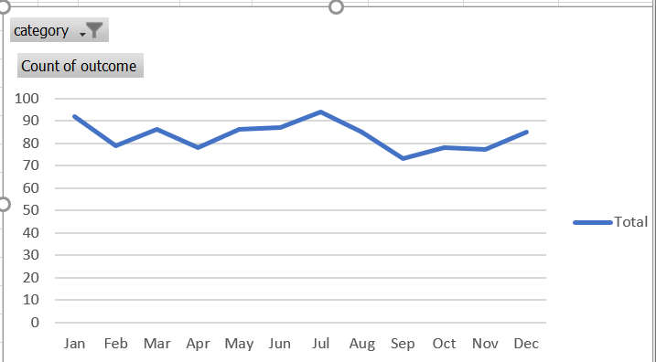

Only Theatres

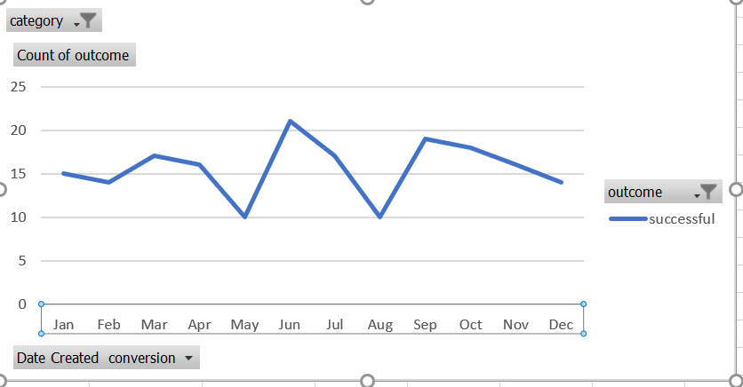

Excluding theaters

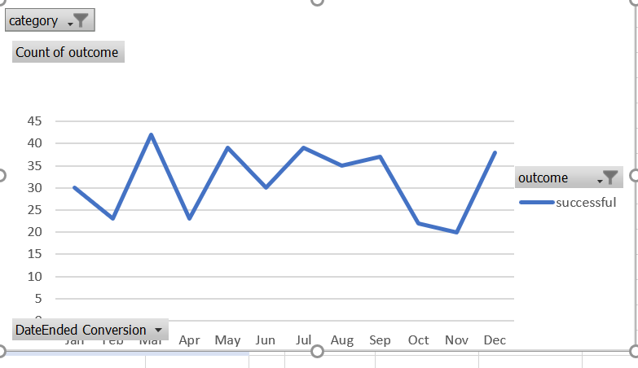

Outcome vs year

